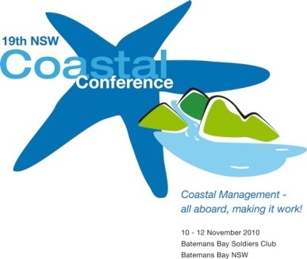
NSW Annual Coastal Management Awards

NOMINATION FORM

Award Category:
------------------------------------------------------------------------------------------------------------------------------------------------------------------------------------------------------------------------------------------------------------------------------

Name of Applicant:
------------------------------------------------------------------------------------------------------------------------------------------------------------------------------------------------------------------------------------------------------------------------------

Affiliation:
------------------------------------------------------------------------------------------------------------------------------------------------------------------------------------------------------------------------------------------------------------------------------
---------------------------------------------------------------------------------------------------------------------------------------

Summary of proposal (max 1page):

Key benefits and features of the nomination (max 1page):

Entries close Friday 22 October 2010

Submission Details
Post:
NSW Coastal Conference
c/- East Coast Conferences
PO Box 848
Coffs Harbour NSW 2450

Fax:
02 6650 9800
\
Email:
amy@eastcoastconferences.com.au

